How to use this template:

First, save a copy of this template. You can either save it directly to your Google Drive, or download it as a Word doc.

Save to Google Drive:

- Step 1: Click File > Make A Copy
- Step 2: Save this file to your Google Drive

Download Word File:

- Step 1: Click File > Download
- Step 2: Select Microsoft Word (.docx)
- Step 3: Save the file to your computer

Note: Please don’t request edit access, you can edit this template once you’ve created a copy.

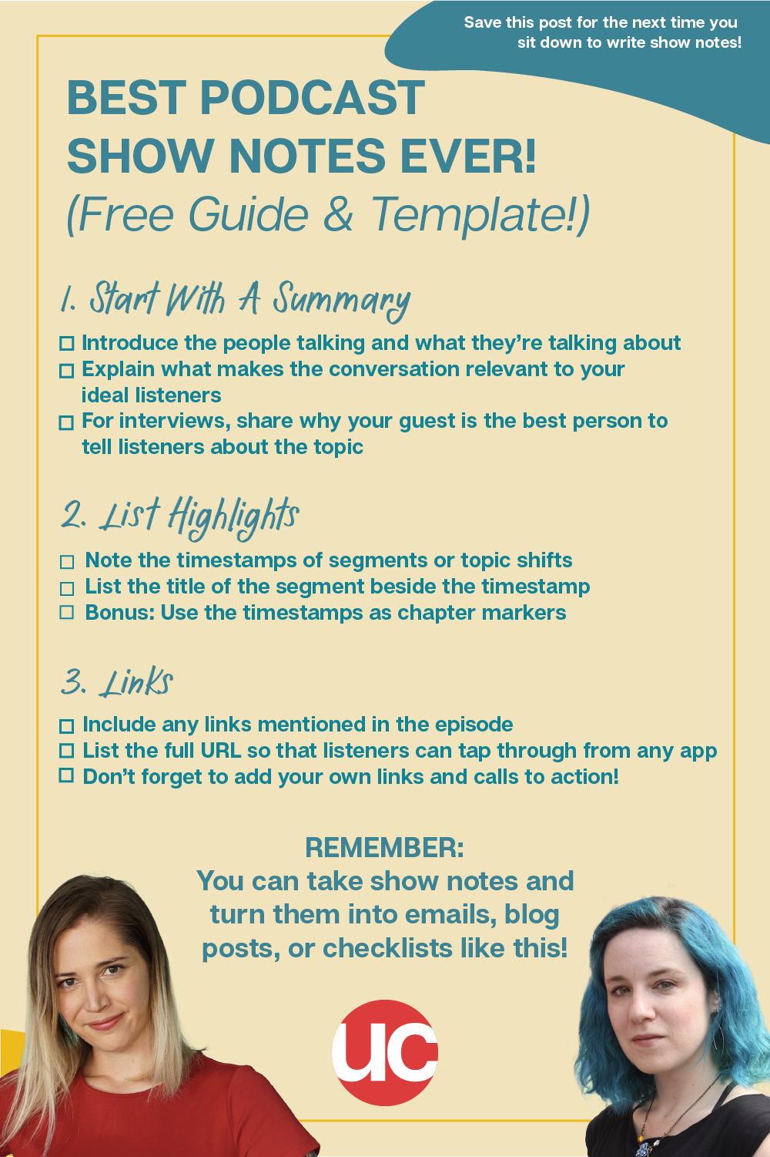

What makes for great podcast show notes?

Your podcast show notes serve a double purpose — you display them on podcast apps to entice listeners, and you can also publish them as blog posts to promote your episodes via your blog! Just make sure that your blog post versions include direct links to the episodes, so that people can easily access them.

REMEMBER:
You can take show notes and turn them into emails, blog posts, or freebies like this!

1. Start With A Summary
- Introduce the people talking and what they’re talking about
- Explain what makes the conversation relevant to your ideal listeners
- For interviews, share why your guest is the best person to tell listeners about the topic

2. List Highlights
- Note the timestamps of segments or topic shifts
- List the title of the segment beside the timestamp
- Bonus: Use the timestamps as chapter markers

3. Links
- Include any links mentioned in the episode
- List the full URL so that listeners can tap through from any app
- Don’t forget to add your own links and calls to action!

Template #1
(general template)

This is a paragraph describing what happens in the episode (and the episode’s title, if applicable). If it’s a conversational podcast, talk about the topics being discussed, who’s doing the talking, and what makes the conversation especially relevant to your ideal listeners. If it’s an interview podcast, introduce your guest(s) and make them sound like the fabulous expert(s) they are, then explain why they’re the best person to tell your audience about their topic(s). This will let potential listeners know how awesome and interesting the ep will be, and why they should listen as soon as possible!

“This is an interesting quote that inspires listeners to learn more.”
- Name of Speaker

Links
Include any links mentioned in the episode here
www.linksmentionedintheep.com

If there are none, don’t worry about it
www.whatijustsaidabove.com

Follow [NAME OF PODCAST OR PODCAST HOST(S)] on [TWITTER OR INSTAGRAM]: @handle(s).

Template #2
(for podcasts with different sections, such podcasts with discrete segments, multiple guests, etc)

This is a paragraph describing what happens in the episode (and the episode’s title, if applicable). If it’s a conversational podcast, talk about the topics being discussed, who’s doing the talking, and what makes the conversation especially relevant to your ideal listeners. If it’s an interview podcast, introduce your guest and make them sound like the fabulous experts they are, then explain why they’re the best person to tell your audience about their topic(s). This will let potential listeners know how awesome and interesting the ep will be, and why they should listen as soon as possible!

“This is an interesting quote that inspires listeners to learn more.”
- Name of Speaker

Highlights
01:00 There is where you put segment titles or
03:45 Names of your interview subjects or
09:33 Whatever else breaks up
15:33 Your podcast into little segments
17:00 So that listeners can find interesting stuff again easily

Links
Include any links mentioned in the episode here
www.linksmentionedintheep.com

If there are none, don’t worry about it
www.whatijustsaidabove.com

Follow [NAME OF PODCAST OR PODCAST HOST(S)] on [TWITTER OR INSTAGRAM]: @handle(s).

